For an undecidable language, there is no Turing Machine which accepts the language and makes a decision for every input string **w** (TM can make decision for some input string though). A decision problem **P** is called “undecidable” if the language **L** of all yes instances to **P** is not decidable. Undecidable languages are not recursive languages, but sometimes, they may be recursively enumerable languages.

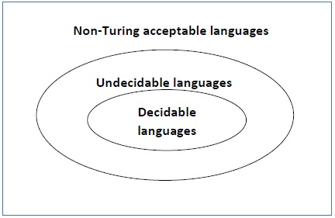

Example

* The halting problem of Turing machine
* The mortality problem
* The mortal matrix problem
* The Post correspondence problem, etc.